Module: Advanced Visualizations (Power BI)
Advanced Visualizations help users interact with reports, analyze data deeply, and improve dashboard usability.

1. Drill-Down & Drill-Through
A. Drill-Down
Drill-down allows users to move from higher-level data to detailed data.
Example
Year → Quater → Month→Days
Steps
- Import Global Superstore dataset.
- Create a Clustered Bar Chart.
- Add:
  - X-axis drag and drop Order date
  - Y-axis drag and drop Sales
- Power BI automatically creates a hierarchy.
- Click Drill Down Mode (↓ icon).
- Click any Region to see States.
- Click State to see Cities.
Business Use
- Sales by Year → Quater → Months→Days
- Product Category → Sub Category → Product
Visualization
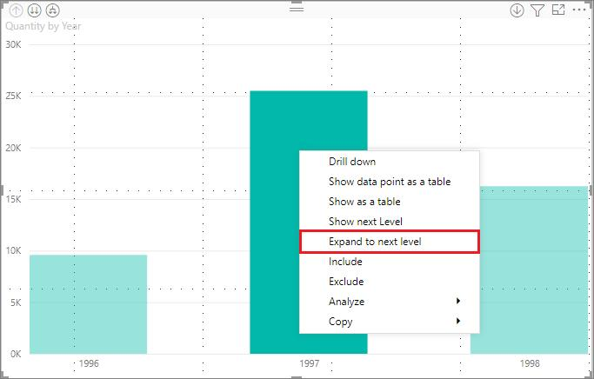
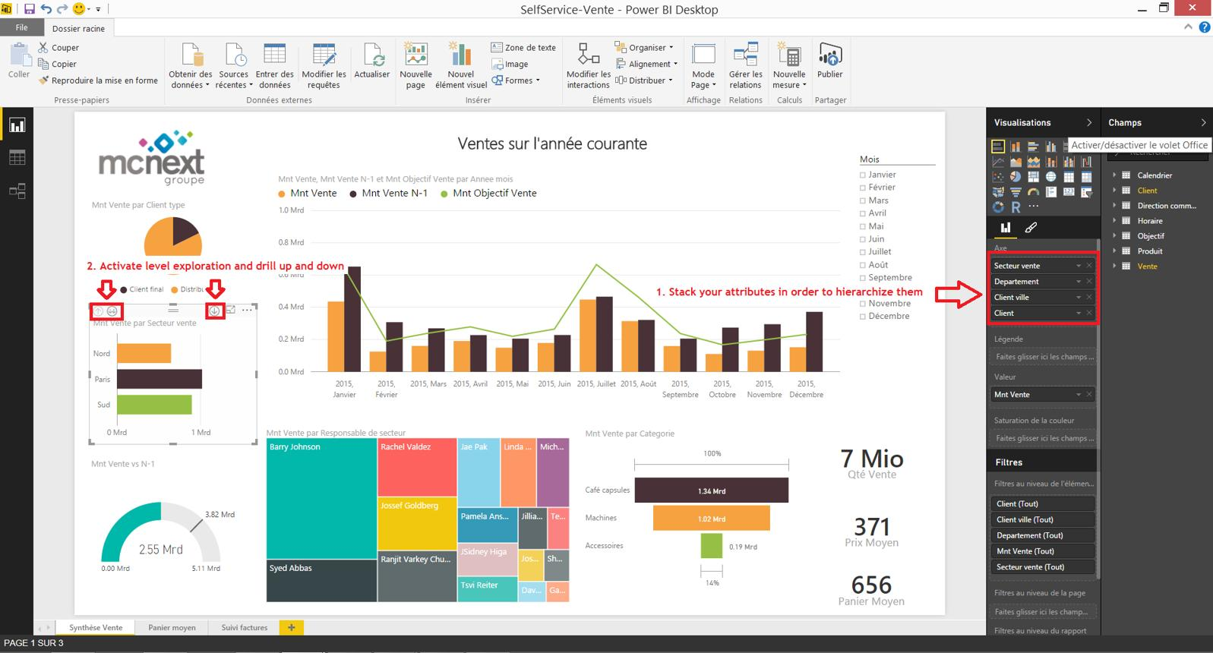
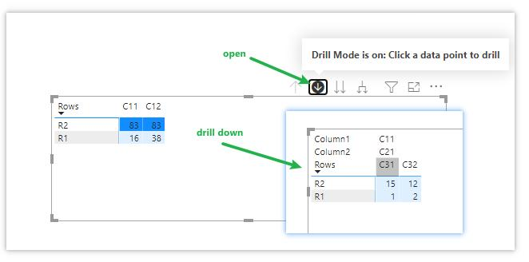

B. Drill-Through
Drill-through allows navigation to a detailed report page. Drill Through takes users from one report page to another page containing detailed information about a selected value.
Example
Sales Summary Page → Customer Details Page
Steps
Page 1: Summary
- Create Sales by Customer chart.
Page 2: Details
- Create a new page.
- Add:
  - Customer Name
  - Order ID
  - Sales
  - Profit
- Drag Customer Name into Drill-through Filters.
Testing
- Go to Summary Page.
- Right-click customer.
- Select Drill Through → Customer Details
Power BI opens detailed customer information.
Benefits
✔ Detailed analysis
✔ Interactive reporting
✔ Better navigation

2. Tooltips Customization
Tooltips display extra information when hovering over visuals.

1st Standard Tooltip
Step-1
Create a Bar chart sales vs sub-category
Step-2
Then select this Bar chart , Go to Build Visual , Go to Tooltips and drag & drop different option like profit , Quantity, shipping cost etc.…
Step-3
Than touch the bar of Bar chart , you will all values are visible like sales, profit, Quantity, shipping cost.
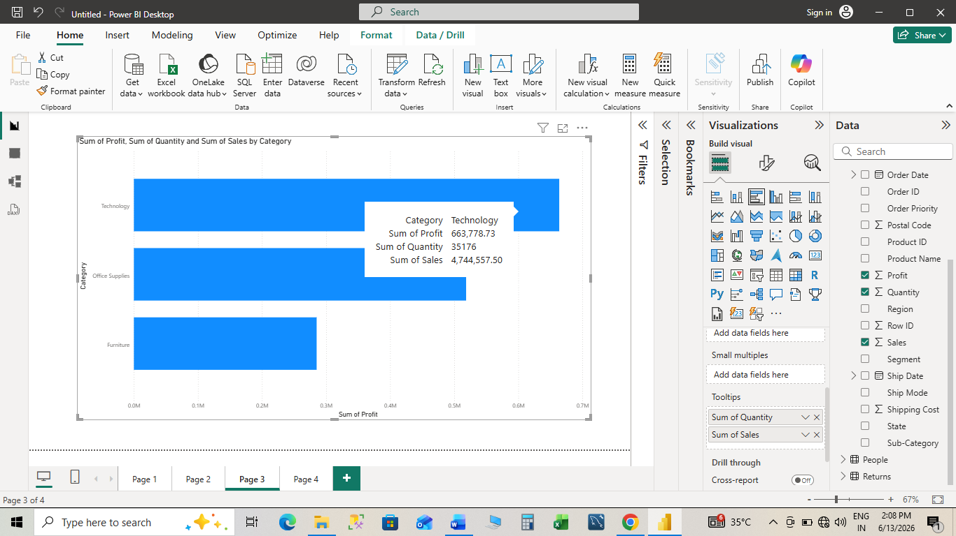

2nd Custom Tooltip Page
Step 1
Create man chart like Sub-category vs sales
Use cluster column chat
Step 2
Go to new sheet, than format page
Than choose canvas setting, under “Type” choose “Tooltipss”
Step 3
Go to main chart , select the main chart, than go to format visual, go to general
Than go to tooltip, than under “page” choose “page2” or chart in tooltip
Than touch the bar of cluster column chart.
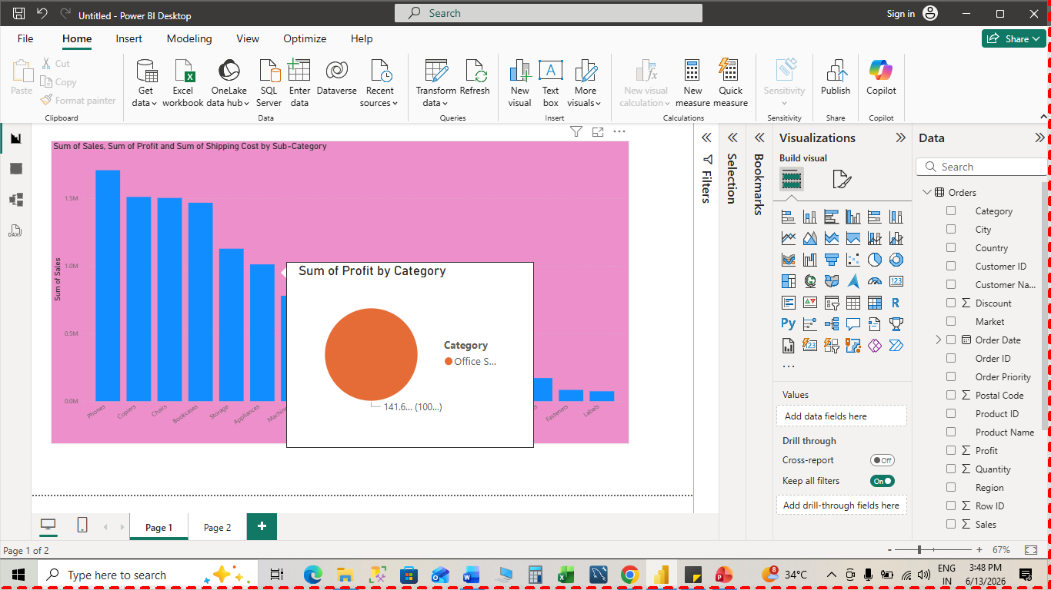

3. Conditional Formatting (Advanced)
Conditional formatting highlights important values automatically.

Example 1: Profit Table
Steps
- Create Table Visual.
- Add:
  - Product
  - Sales
  - Profit
- Select Profit Column.
- Choose:
Format → Conditional Formatting
Options
- Background Color
- Font Color
- Icons
- Data Bars

Rule Example
Profit | Color
< 0 | Red
0-500 | Yellow
>500 | Green

KPI Icons
Profit | Icon
Loss | 🔴
Average | 🟡
Good | 🟢

Business Use
- Identify losses
- Highlight top performers
- Monitor KPIs
Visualization
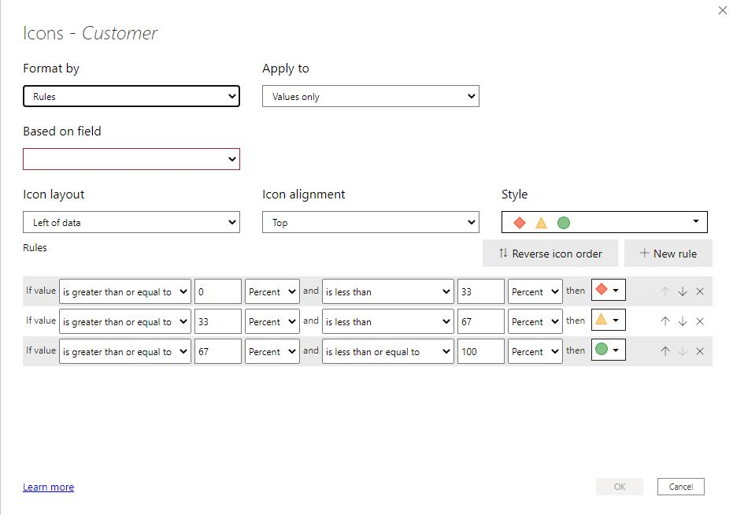
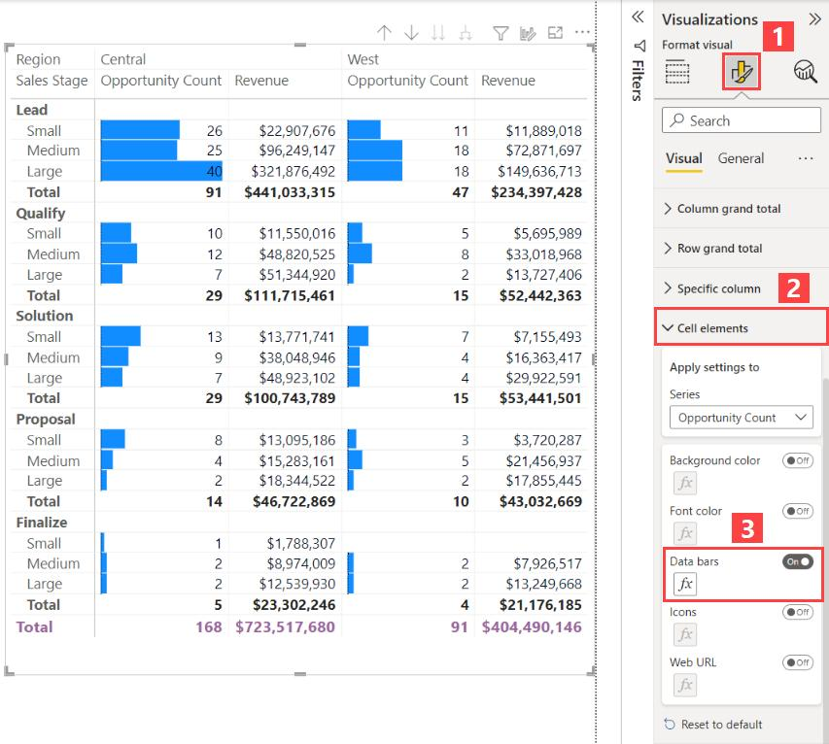
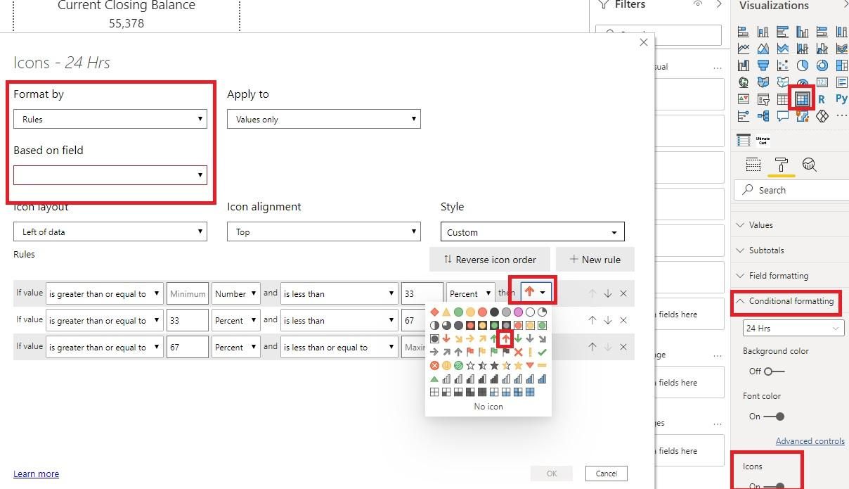

4. KPI Indicators & Gauges
KPIs measure performance against targets.

KPI Visual
Example
Current Sales = ₹950K
Target Sales = ₹1M
Achievement = 95%

Steps
- Create Measures:
Total Sales =
SUM(Orders[Sales])
Target Sales =
1000000
- Insert KPI Visual
- Add:
- Indicator → Total Sales
- Target → Target Sales
- Trend Axis → Order Date

Gauge Visual
Gauge displays progress toward target.
Steps
- Insert Gauge Visual.
- Add:
  - Value = Total Sales
  - Target = Target Sales
Result
Power BI displays speedometer-style KPI.

Sample KPI Achievement
KPI achievement example
Current sales compared with target sales.
₹0₹300K₹600K₹900K₹1.2MCurrent SalesTarget Sales

Business Use
- Sales Targets
- Revenue Goals
- Profit Monitoring
- Customer Satisfaction Scores

5. Bookmark Navigation
Bookmarks create app-like navigation inside Power BI reports.

What is Bookmark?
A bookmark saves:
- Current Filters
- Current Visual State
- Current Page

Example
Dashboard contains:
- Sales View
- Profit View
- Customer View
Instead of multiple pages, buttons switch views.

Steps
Step 1
Create all visuals.
Step 2
Open:
View → Bookmarks Pane
Step 3
Hide Visuals
Keep only Sales Visual visible.
Step 4
Add Bookmark
Name:
- Sales
- Profit
- Customer
Step 5
Insert Buttons
Insert → Buttons
Step 6
Assign Actions
Action → Bookmark
Select desired bookmark.

Result
Users click buttons and dashboard changes instantly.

Visualization
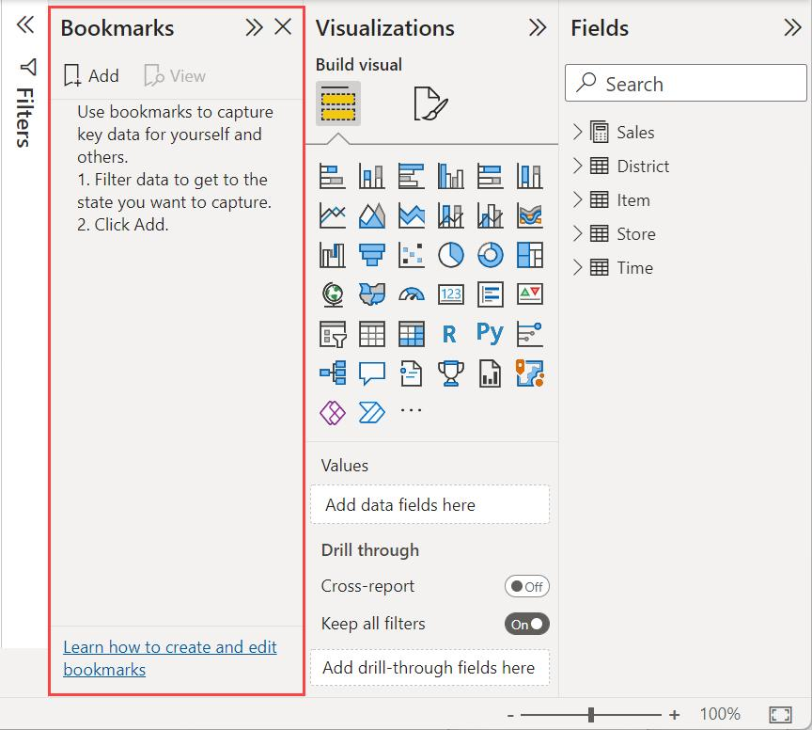
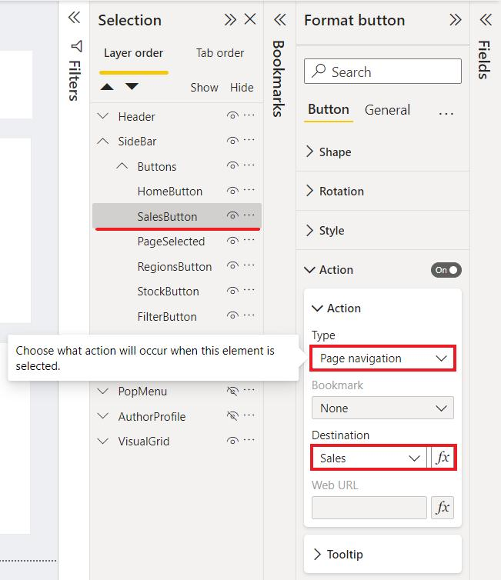
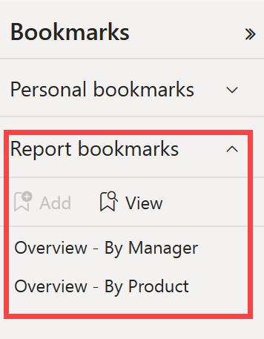

Interview Questions
Q1. Difference between Drill-Down and Drill-Through?
Drill-Down | Drill-Through
Same visual | Different page
Hierarchical analysis | Detailed analysis
Region → State | Customer → Details

Q2. Why use Custom Tooltips?
Answer: To display additional insights without occupying dashboard space.

Q3. What are Bookmarks used for?
Answer: To create interactive navigation, storytelling dashboards, and app-like report experiences.

